Seven Reasons To Forgive Your Ex
by Eileen Barker (@thewelife) on Feb 14, 2014 8:26pm
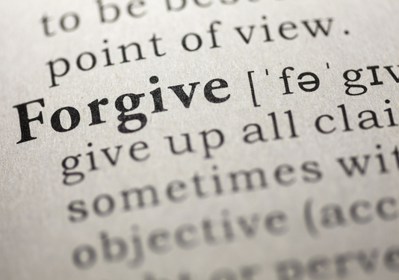
Let’s face it. It’s hard to end a marriage without some degree of anger, resentment, disappointment or guilt creeping in. In the old days, it was expected that divorcing spouses would basically be enemies for the rest of their lives. We know now that is unnecessary.
Most people, given the choice, want to have an amicable divorce. Yet, intense emotions such as anger, grief, fear, and mistrust can make this difficult. In the face of strong and painful feelings, it can be hard to cooperate, co-parent effectively, or even participate in mediation.
Once a divorce gets off to a rocky start, the situation can quickly spiral down. Many people find themselves caught in vicious cycles of hurt, anger, and retaliation, even when they don’t want to be. Left unchecked, many couples end up reenacting the War of the Roses, engaging in an endless stream of battles and spending tens of thousands of dollars on legal fees in the process. Even for cases that settle, it is common for each spouse to pay attorney fees of $50,000-100,000 and much more. The good news is that it is never too late to change gears.
It may surprise you to learn that one of the most effective tools, especially in emotionally charged, high conflict divorces, is forgiveness. Forgiveness may seem like the last thing you’d want to consider when you are upset with your ex-spouse, but here are seven reasons why you should:
- Forgiveness is for your own benefit, not your ex’s benefit. In fact, you need not ever tell your ex that you have forgiven them, unless you choose to do so.
- Forgiveness does not mean condoning bad behavior, and it does not mean forgetting what occurred. It means making peace with what has occurred so that you can put the past behind you.
- A good forgiveness process helps you turn the corner on feeling helpless and/or victimized by your ex, and shows you how to reclaim your power over your life and well-being.
- Forgiveness allows you to release difficult emotions, including blame, anger and grief — without denying or minimizing your feelings. It provides a way to acknowledge feelings, heal and move on.
- Anger and resentment are toxic to you and everyone around you. No matter how justified or right you feel, perpetuating conflict is not in anyone’s best interest. Scientific studies have proven that anger and resentment are damaging to your health and happiness.
- Divorce research shows that one of the most damaging aspects of divorce for children is exposure to ongoing conflict and/or being placed in the middle of it. (This is not to say that you shouldn’t protect yourself and your children if there is a threat of danger. Obviously you should, but protective action does not require hostility.)
- The pleasure of getting even is short-lived. The best revenge is a happy life. As Oscar Wilde put it: “Always forgive your enemies. Nothing infuriates them so.”
Sooner or later most people do want to resolve their marital conflicts and move on. So the question is, how long will you wait? How much suffering is enough? Who is your anger hurting? You don’t need to wait until the divorce is final and all the dust settled. Forgiveness is possible — and powerful — at any stage.
Years ago, when I led my first forgiveness training, one of the students told me she had just found out that her husband had been seeing another woman, and had announced that he was leaving her. She was adamant that she would never forgive him, and didn’t want to have anything to do with him, even though they still had a son in high school. In fact, she decided to work on a different conflict during the forgiveness class. However, when she returned to class the second day, she reported that everything had changed. After the first day of class she had come to understand her husband on a level she hadn’t before seen. She said she had forgiven him, and was now certain she would be able to have an amicable relationship with him, and be able to co-parent their son. She later reported that because of her forgiveness work, the process of getting divorced was relatively simple.
Many people realize they need to forgive, and want to forgive, but don’t know how. Fortunately, there are many resources available. (For a free guide on “How to Forgive Your Ex: 8 Essential Steps,” click here.)
Remember, it is never too soon or too late to forgive. Some people wait until years after the divorce is final, and others, like the woman in my class, forgive at the onset. The key is this: The past does not dictate the future unless you let it. Even if things have been very difficult in the past, you always have the ability to forgive in the present. When you do, you open a doorway to peace, both inner and outer. And if even only one of you can see this, it will make a world of difference.

Related: Divorce, Forgiveness, Forgiving The Ex
Eileen BarkerDivorce mediator and forgiveness coach at The Path of Forgiveness

